ProfileUnity™ 6.5.x

Windows Local
GPO Configuration

Introduction
This guide has been authored by experts at Liquidware Labs in order to provide information and guidance concerning the evaluation process and normal use cased of ProfileUnity 5.2 with FlexApp technology.
Information in this document is subject to change without notice. No part of this publication may be reproduced in whole or in part, stored in a retrieval system, or transmitted in any form or any means electronic or mechanical, including photocopying and recording for any external use by any person or entity without the express prior written consent of Liquidware Labs.

Liquidware Labs, Inc.
3600 Mansell Road
Suite 200
Alpharetta, Georgia 30022
U.S.A.
Phone: 678-397-0450
www.liquidwarelabs.com

©2012 Liquidware Labs Inc. All rights reserved. Liquidware Labs, Stratusphere FIT, Stratusphere UX Stratusphere IXD, FlexApp, and ProfileUnity are trademarks of Liquidware Labs. All other products are trademarks of their respective owners. 12-0925

Contents
GPO Settings for ProfileUnity 3
Computer Settings 3
User Settings 3
Configuring the GPO for ProfileUnity 4
Windows Local GPO 4
Computer Configuration Settings 4
User Configuration Settings 10

GPO Settings for ProfileUnity
ProfileUnity requires both computer and user GPO settings to be applied for ProfileUnity to execute for users. These settings may be applied in a single or multiple GPO’s.

Computer Settings
LWL.ProfileUnity.Client.Startup.exe (required) – Caches the ProfileUnity application files on the local computer C: drive.
Loop Back Processing Mode – applies user GPO settings to the users which logon to the computer. (Required when applying a single GPO to only to the Computer OU.)
Auto Install .Net (optional)– installs .Net if it is not already installed.
System INI File Path (optional) – This is the UNC path for the ini file when the “Run Client Tools As Service” is used.
System License Path (optional)– This is the path to the ProfileUnity.lic license file.
Temp Path (optional) – Local Path containing the ProfileUnity Temp files. By default, this is the User's %temp% folder.
Client Service Credentials Path (Required when Running ProfileUnity as a Service) - Path to the client service exe's credentials file. This is the location where you extracted the ProfileUnity files (by default the Netlogon\ProfileUnity folder).
ProfileDisk Nodes Path (optional)- Path to ProfileDisk's nodes.xml configuration file. This is the location where you extracted the ProfileUnity files (by default the Netlogon\ProfileUnity folder).

User Settings
LWL.ProfileUnity.Client.Logoff.exe (required) – executes ProfileUnity at logoff
INI File Path - UNC Path containing the ProfileUnity INI configuration files.
License Path - UNC Path containing the ProfileUnity License file.
Enabled (required) – enables ProfileUnity to run for the user
Silent (optional) – disables the ProfileUnity splash screen
Disable Timestamp (optional) – disable timestamp checking of the portability 7z files. All portability settings are saved at logoff and restored at logon without comparing the timestamp.

Configuring the GPO for ProfileUnity

Windows Local GPO

ProfileUnity manages users through Group Policy startup scripts, logoff scripts and ADM template settings.

Computer Configuration Settings

Configuring the Group Policy Startup Script

- Run gpedit.msc.

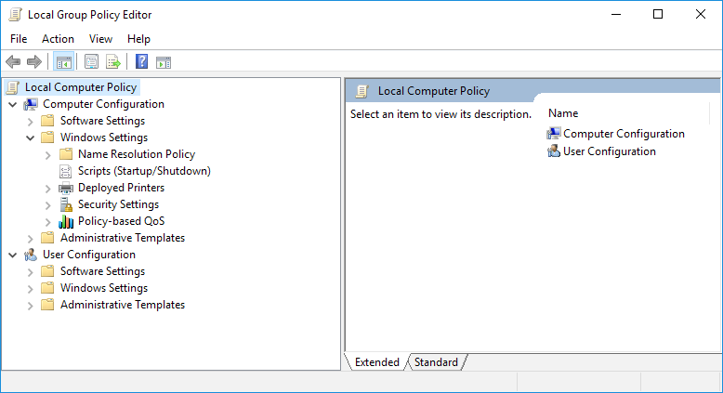

- Browse to Computer Configuration\Windows Settings\Scripts (Startup/Shutdown) and edit the properties of the Startup script.

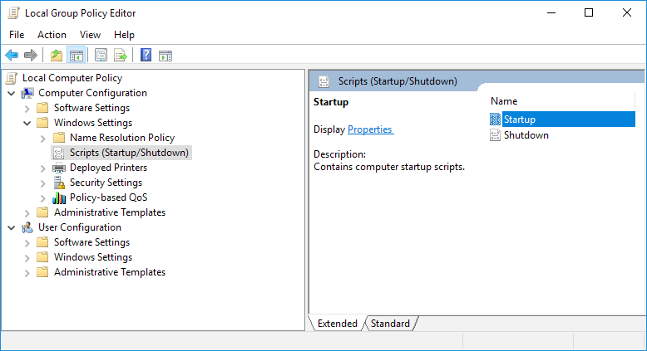

- Click the Add button to add a new startup script.

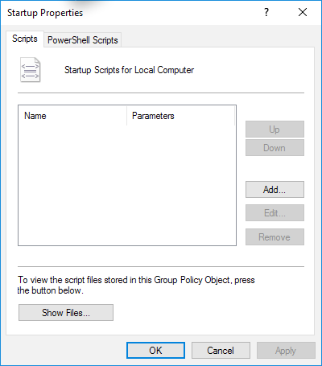

- Assign LwL.ProfileUnity.Client.Startup.exe as a startup script.
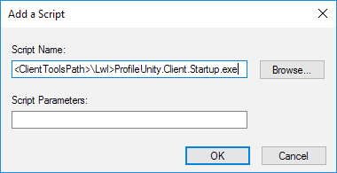

Script Name: <ClientTools Path >\LWL.ProfileUnity.Client.Startup.exe
Script Parameters: leave blank

NOTE: You will need to replace <ClientTools Path> in the above example with the UNC path to LWL.ProfileUnity.Client.Startup.exe file. This is the location where you extracted the ProfileUnity files (by default the Netlogon\ProfileUnity folder) and select the ProfileUnity.adm template.

Adding the ProfileUnity ADM Template

ADM Template settings under Computer Configuration are optional and only need to be set for specific use cases.

- Under the policy, browse to Computer Configuration\Administrative Templates.
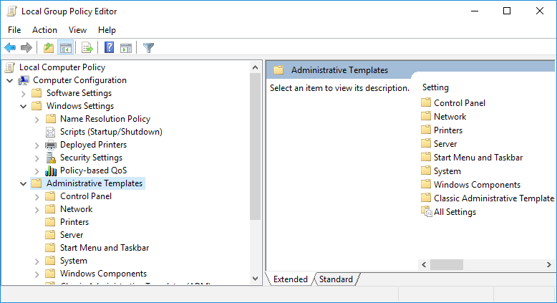

- Right click on Administrative Templates and select Add/Remove Templates…

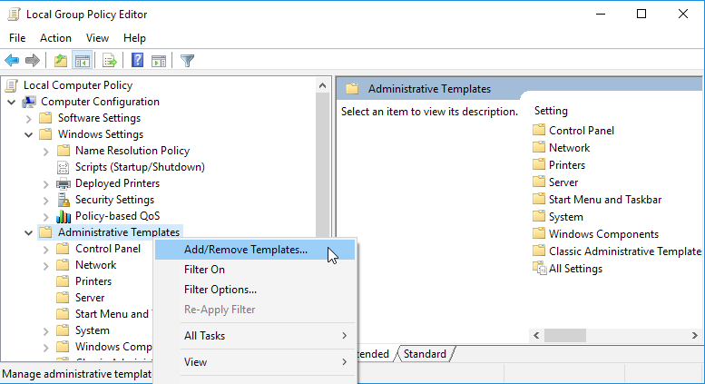

- Click the Add button to add a new template.

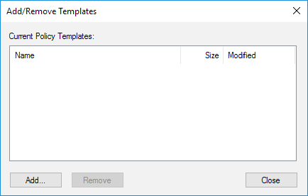

- Browse to the location where you extracted the ProfileUnity files (by default the Netlogon\ProfileUnity folder) and select the ProfileUnity.adm template.

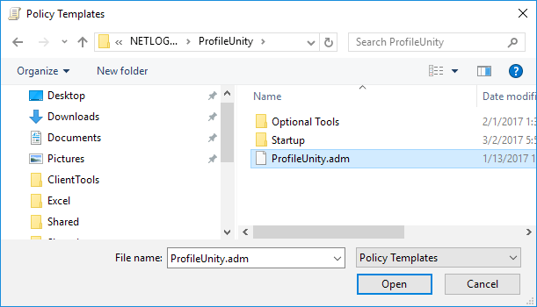

- Click Open, and then on the next dialog click Close.

Optional Computer Configuration Settings

- Under Computer Configuration > Administrative Templates > Classic Administrative Templates > Liquidware Labs> ProfileUnity select 32 Bit or 64 Bit depending on the bit level of your target operating systems.
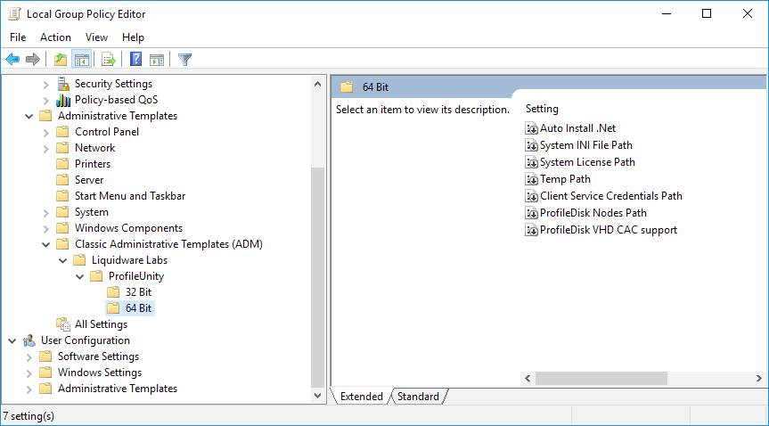
The following option may be set:
Auto Install .Net – installs .Net if it is not already installed.
System INI File Path – This is the UNC path for the ini file when the “Run Client Tools As Service” is used.
System License Path – This is the path to the ProfileUnity.lic license file.
Temp Path – Local Path containing the ProfileUnity Temp files. By default, this is the User's %temp% folder.
Client Service Credentials Path - Path to the client service exe's credentials file. This is the location where you extracted the ProfileUnity files (by default the Netlogon\ProfileUnity folder).
ProfileDisk Nodes Path - Path to ProfileDisk's nodes.xml configuration file. This is the location where you extracted the ProfileUnity files (by default the Netlogon\ProfileUnity folder).
ProfileDisk VHD CAC Support - ProfileDisk when leveraging CAC requires a setting so we know to impersonate the ProU as a service user when connecting to the file share. We can NOT impersonate a CAC user for security reasons. We leverage ProU as a service user name and password. This also means the minimum requirement for ProfileDisk VHD with CAC, is to have the ProU as a service account full control on the file share. When it comes to ProfileDisk VMDK and CAC this setting is NOT required.

User Configuration Settings

If you are splitting the GPO between Computers and Users, create another GPO and link it to the users OU. You may filter the GPO to the ProfileUnity license group.
If you are using a single GPO, continue modifying the previous GPO.

Group Policy Logoff Script

- Under the policy browse to User Configuration\Windows Settings\Scripts (Logon/Logoff) right click on Logoff and select Properties:
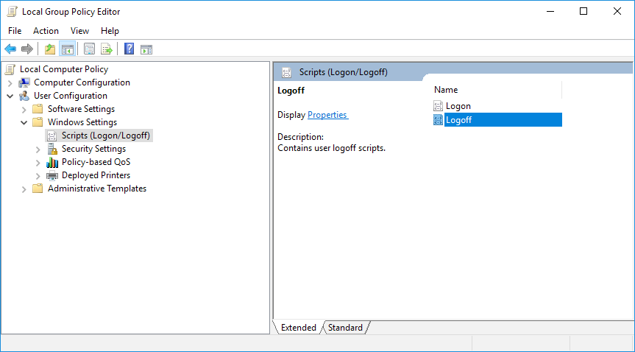

- Click Add to add a new logoff script:

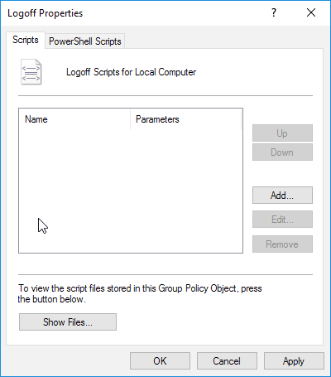

- Point the script parameters to your domain’s netlogon share.

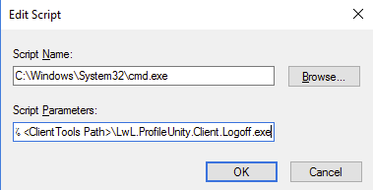

Script Name: C:\windows\system32\cmd.exe
Script Parameters: /c cd %temp% & <ClientTools Path >\LWL.ProfileUnity.Client.Logoff.exe

NOTE: You will need to replace <ClientTools Path> in the above example with the UNC path to LWL.ProfileUnity.Client.Logoff.exe file. This is the location where you extracted the ProfileUnity files (by default the Netlogon\ProfileUnity folder) and select the ProfileUnity.adm template.

- Click OK and then Apply to save your changes.

Configuring and Enabling the User administrative template settings

Browse to the “User Configuration\Administrative Templates\Liquidware Labs\ProfileUnity” path.

- Right click on Enabled and select “Properties”, select “Edit”

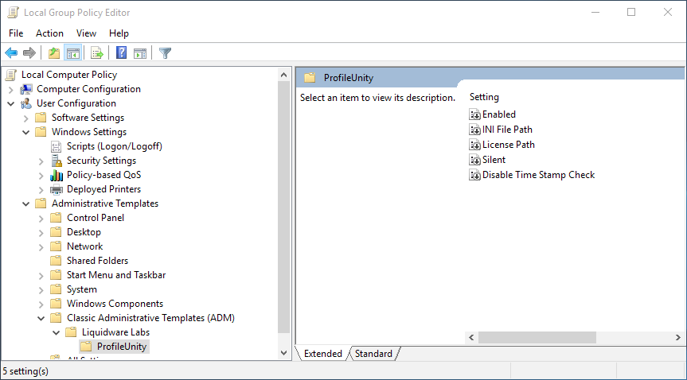

- Select the “Enabled” Radial button, and then click OK.

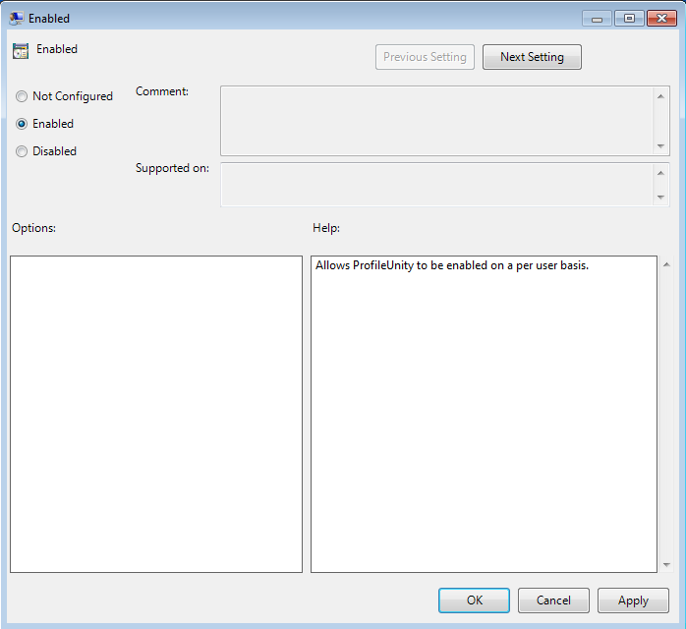

- Right click on “INI File Path” and select “Edit”.

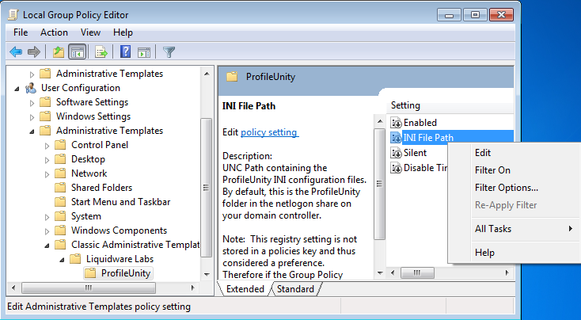

- Select the “Enabled” radial button.

- Edit the UNC Path to match the folder where your INI files will be stored. This is the location where you extracted the ProfileUnity files (by default the Netlogon\ProfileUnity folder). Then click the OK button.

